**UNIT 1**

**PRINCIPLES OF MANAGEMENT**

**Introduction**

Management is essential to any organization that wishes to be efficient and achieve its aims. Without someone in a position of authority there would be organizational anarchy with no structure and very little, if any focus. It has been said that management has four basic functions – planning, organizing, leading and controlling. Common sense dictates that without these principles of management being in place an organization would have trouble achieving its aims.

**Meaning :-** Management is the process of conducting a set of functions, such as , planning , organizing, staffing, directing, and controlling to get the work done in an efficient and effective manner.

Nature Of Management

1. Art as well as a science:Management is both an art of possessing of managing skill by a person and a science because of developing certain principles or laws applicable in place where a group of activities are coordinated.

2. Management is a discipline:The boundaries of management are not exact like other physical science. It may be increased by continuous discovery of more aspects of business enterprise.

3. Organized activities:The success of any management activity is accessed by its achievement of the predetermined goals or objective. Management is a purposeful activity. It is a tool, which helps use of human and physical resources to fulfill the pre-determined goals. For example, the goal of an enterprise is maximum consumer satisfaction by producing quality goods and at reasonable prices. Employing efficient persons and making better use of scarce resources can achieve this.

4. Management is achieving pre-determined objectives:Management is a group of organized activities. It can be in the form of limited company or a small club. All organizations have objectives and these objectives are achieved through systematic way of organized activities.

5.Management is Continuous:Management is an ongoing process. It involves continuous handling of problems and issues. It is concerned with identifying the problem and taking appropriate steps to solve it, e.g. the target of a company is maximum production. For achieving this target various policies have to be framed but this is not the end. Marketing and Advertising is also to be done. For this policies have to be again framed. Hence this is an ongoing process.

6.Decision-making. Decision making arises because there is availability courses of actions, the quality of decision taken determines the organisation performance.

7.Management is a profession:Managers get things done by others.

8.Management is all Pervasive:Management is required in all types of organizations whether it is political, social, cultural or business because it helps and directs various efforts towards a definite purpose. Thus clubs, hospitals, political parties, colleges, hospitals, business firms all require management. Whenever more than one person is engaged in working for a common goal, management is necessary.

Importance Of Management

1.Helps in Achieving Group Goals:Management converts disorganized resources of men, machines, money etc. into useful enterprise. It arranges, assembles, organizes and integrates the factors of production. These resources are coordinated, directed and controlled in such a manner that enterprise work towards attainment of goals.

2.Optimum Utilization of Resources:Management utilizes all the physical and human resources productively. Management provides maximum utilization of scarce resources by selecting its best possible alternate use in industry from out of various uses. This leads to optimum utilization of resources and avoid wastage

3.Reduces Costs:It gets maximum results through minimum input by proper planning and by using minimum input and getting maximum output. Management uses physical, human and financial resources in such a manner, which results in best combination. This helps in cost reduction.

4.Establishes Sound Organization:To establish sound organizational structure is one of the objective of management which is in tune with objective of organization and for fulfillment of this, it establishes effective authority and responsibility relationship i.e. who is accountable to whom, who can give instructions to whom, who are superiors and who are subordinates.

5.Establishes Equilibrium:It enables the organization to survive in changing environment. It adapts organization to changing demand of market/changing needs of societies. It is responsible for growth and survival of organization.

6.Essentials for Prosperity of Society:Efficient management leads to better economical production which helps in turn to increase the welfare of people. It improves standard of living, increases the profit which is beneficial to business and society will get maximum output at minimum cost by creating employment opportunities which generate income.

**Principles of Management**

* Division of Work
* Authority
* Discipline
* Unity of command
* Unity of direction
* Subordination of individual interests to general interests
* Remuneration to personnel
* Centralization
* Scalar chain
* Order
* Equity
* Initiative
* Esprit de crop
* Span of control
* Motivation

Process/Function Of Management

**Motivation**

**Leadership**

**Supervision**

**Communication**

* **Planning :-** It is the basic function of management. It deals with chalking out a future course of action & deciding in advance the most appropriate course of actions for achievement of pre-determined goals. According to KOONTZ, “Planning is deciding in advance - what to do, when to do & how to do. It bridges the gap from where we are & where we want to be”. A plan is a future course of actions. It is an exercise in problem solving & decision making. Planning is determination of courses of action to achieve desired goals. Thus, planning is a systematic thinking about ways & means for accomplishment of pre-determined goals. Planning is necessary to ensure proper utilization of human & non-human resources.
* **Organising:**- it is the process of bringing together physical, financial and human resources and developing productive relationship amongst them for achievement of organizational goals. According to Henry Fayol, “To organize a business is to provide it with everything useful or its functioning i.e. raw material, tools, capital and personnel’s”. To organize a business involves determining & providing human and non-human resources to the organizational structure.
* **Staffing:**- It is the function of manning the organization structure and keeping it manned. Staffing has assumed greater importance in the recent years due to advancement of technology, increase in size of business, complexity of human behavior etc. The main purpose o staffing is to put right man on right job i.e. square pegs in square holes and round pegs in round holes. According to Kootz & O’Donell, “Managerial function of staffing involves manning the organization structure through proper and effective selection, appraisal & development of personnel to fill the roles designed un the structure”.
* **Directing:-** It is that part of managerial function which actuates the organizational methods to work efficiently for achievement of organizational purposes. It is considered life-spark of the enterprise which sets it in motion the action of people because planning, organizing and staffing are the mere preparations for doing the work. Direction is that inert-personnel aspect of management which deals directly with influencing, guiding, supervising, motivating sub-ordinate for the achievement of organizational goals. Direction has following elements:
  + Supervision
  + [Motivation](https://www.managementstudyguide.com/what_is_motivation.htm)
  + [Leadership](https://www.managementstudyguide.com/leadership_basics.htm)
  + [Communication](https://www.managementstudyguide.com/understanding-communication.htm)
* Supervision**-** implies overseeing the work of subordinates by their superiors. It is the act of watching & directing work & workers.
* **Motivation-** means inspiring, stimulating or encouraging the sub-ordinates with zeal to work. Positive, negative, monetary, non-monetary incentives may be used for this purpose.
* **Leadership-** may be defined as a process by which manager guides and influences the work of subordinates in desired direction.
* **Communications-** is the process of passing information, experience, opinion etc from one person to another. It is a bridge of understanding.
* **Controlling:-** it implies measurement of accomplishment against the standards and correction of deviation if any to ensure achievement of organizational goals. The purpose of controlling is to ensure that everything occurs in conformities with the standards. An efficient system of control helps to predict deviations before they actually occur. According to *Theo Haimann*, “Controlling is the process of checking whether or not proper progress is being made towards the objectives and goals and acting if necessary, to correct any deviation”.

**Managerial Roles**

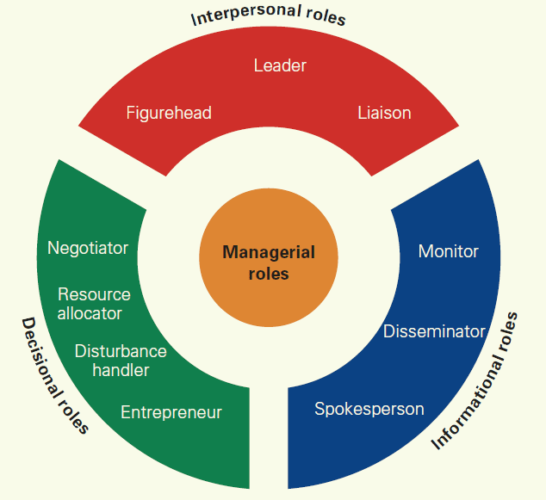

### **Interpersonal Roles**

1. **Figurehead** **–**As a manager, you have social, ceremonial and legal responsibilities. You're expected to be a source of inspiration. People look up to you as a person with authority, and as a figurehead.
2. **Leader** –This is where you provide leadership for your team, your department or perhaps your entire organization; and it's where you manage the performance and responsibilities of everyone in the group.
3. **Liaison** –Managers must communicate with internal and external contacts. You need to be able to network effectively on behalf of your organization.

### **Informational Roles**

**4.Monitor** – In this role, you regularly seek out information related to your organization and industry, looking for relevant changes in the environment. You also monitor your team, in terms of both their productivity, and their well-being.

**5.Disseminator** – This is where you communicate potentially useful information to your colleagues and your team.

**6.Spokesperson** – Managers represent and speak for their organization. In this role, you're responsible for transmitting information about your organization and its goals to the people outside it.

### **Decisional Roles**

### 7.**Entrepreneur** – As a manager, you create and control change within the organization. This means solving problems, generating new ideas, and implementing them.

**8.Disturbance Handler** – When an organization or team hits an unexpected roadblock, it's the manager who must take charge. You also need to help mediate disputes within it.

**9.Resource Allocator** –You'll also need to determine where organizational resources are best applied. This involves allocating funding, as well as assigning staff and other organizational resources.

**10.Negotiator** –You may be needed to take part in, and direct, important negotiations within your team, department, or organization.

**Managerial Skills**

***Conceptual skill Human Skill Technical Skill***

#### **Conceptual Skills**

These involve the skills managers present in terms of the knowledge and ability for abstract thinking and formulating ideas. The manager is able to see an entire concept, analyze and diagnose a problem, and find creative solutions. This helps the manager to effectively predict hurdles their department or the business as a whole may face.

#### **Human or Interpersonal Skills**

The human or the interpersonal skills are the skills that present the managers’ ability to interact, work or relate effectively with people. These skills enable the managers to make use of human potential in the company and motivate the employees for better results.

1. **Technical Skills**

Technical skills involve skills that give the managers the ability and the knowledge to use a variety of techniques to achieve their objectives. These skills not only involve operating machines and software, production tools, and pieces of equipment but also the skills needed to boost sales, design different types of products and services, and market the services and the products.

APPROACHES TO MANAGEMENT

**Theories of Management**

**Modern Approach**

**Neo –Classic Approach**

**Classic Approach**

**Quantitative Approach**

**System Approach**

**Behavioural Approach**

**Human Relation Approach**

**Bureaucratic Management Approach**

**Administrative Management Approach**

**Scientific Management Approach**

**Contingency Approach**

**1.CLASSICAL APPROACHES**

1. **SCIENTIFIC MANAGEMENT APPROACH:-**

F. W. Taylor is the father of scientific management. In addition to Taylor; Frank and Lillian Gilbreth , Henry L. Gantt and Harrington Emerson have also made significant contribution to the development of scientific management.

***Meaning Of Scientific Management:-***

The literary meaning of scientific management is performing the work of management in a scientific manner. In other words; discarding the traditional approaches to management and adopting newer and more scientific approaches in their place is called scientific management.

***Principles Of Scientific Management***

The Scientific Management Approach propounded by F. W. TAYLOR is based upon the following five principles:

* **Principle of the use of science for the Rule of Thumb:**

According to this principle, all the activities being performed in an organisation should be analysed in detail with the aim of developing a technique of accomplishing the maximum possible work in an efficient manner and at the minimum possible cost.

* **Principle of Scientific selection and Training of workers:**

According to this principle, the selection and training of workers should be done in a scientific manner. Of the various activities being performed in an organisation, selection of the workers is the most important because even one wrong appointment can spoil the whole atmosphere in the organisation.

* **Principle of Cooperation between Labour and Management**:

As per this principle, Labour should understand that it cannot proceed in its work without the existence of Management, and Management should understand that it has no identity without the existence of labour.

* **Principle of Maximum output:**

As per this principle, both the labour as well as management should make full efforts to produce the maximum output. They should spare no efforts for the maximum utilisation of the factors of production available in the organisation.

* **Principle of division of Responsibility**:

According to this principle, the work of the organisation and the related responsibilities should be clearly divided among the two main groups in the organisation. Each group should be assigned work which it can accomplish more efficiently.

***Benefits or importance of Scientific Management:***

Scientific management is equally important to employers, workers and the society as a whole. This technique of management believes in balanced development of all the sections of society. On this basis the various benefits of Scientific management can be grouped under the following three headings:

* **Benefits to Employers:**

Scientific Management results in the following benefits to employers or owners of the business:

* **Maximum Production:** The quantity of output is directly related to the efficiency of workers and Scientific management concentrates is efforts on increasing the efficiency of workers.
* **Industrial Peace: -** One of the main aims of scientific management is bringing about a mental revolution in the mind – sets of the management and the workers.
* **Benefits of Specialisation:-** Scientific management involves in breaking up the complete work into many small parts, with each part being assigned to a person who is an expert in performing it.
* **Benefits to workers**

The adoption of a system of scientific management has the following benefits for workers.

* **Better Working Condition:-**Scientific management involves the maintenance of proper cleanliness and ventilation at the work place and also making adequate arrangements for the safety of workers.
* **More Remuneration:-** Scientific management involves, on the one hand, the provision of proper working conditions and, on the other hand, implementation of differential wage system.
* **Improvement in Standard of Living:-** The two main requisites of a good standard of living are money and peace. Scientific management provide its workers with both these things.

***DEMERITS OF SCIENTIFIC MANAGEMENT***

Even though the advent of scientific management resulted in a revolution in the industrial world which resulted in an unprecedented increase in the efficiency of employees, the system cannot be said to be completely faultless. Many industrialists and the working class have bitterly criticized this system. The main faults or criticisms of scientific management are:

* **Criticisms By Owners**

The owners of the businesses have criticized scientific management on the following grounds:

* **Difficult to Introduce:-**It requires a complete change in the structure of the organisation and also results in frequent interruptions in the process of production.
* **Only suitable for Large – Scale Business:-** Since this is a very complex and expensive system to implement, it can be implemented only in large scale organizations.
* **Dependency on Experts:-** This system requires the appointment of experts in order to take benefit of their experience and expertise. All the work in the organisation is done according to the instructions of the experts only.
* ***Criticisms by Workers***

Workers are critical of scientific management due to the following reasons:-

* **Fear of Retrenchment**:- One of the main aims of scientific management is increase in productivity. The implementation of a scientific management system increases efficiency which is very beneficial for the organisation.
* **Lack of Initiative**:- In such a system all the major work is allotted to experts, and workers have no choice but to work as per their instructions.
* **Inhuman Behaviour**:- Under this system, the owners are only concerned about the increase in production and totally ignore the adverse effect of the additional burden of work has on the health of the employees.

**b.Administrative Management Approach**

Administrative Management Approach to Management was advocated by Henry Fayol. This approach is also called process Management. Fayol is also called the father of administrative management in the same way as Taylor is called the father of Scientific Management. He acquired the knowledge of management by working as a manager in various companies in France.

This conclusion of Fayol brings out two features of management: (1) that management is an activitiy which is different from other business activities, and (2) that management has the quality of being universal.

***FUNCTIONS OF MANAGEMENT ACCORDING TO FAYOL***

1. PLANNING (**2**) ORGANISING (**3**) COORDINATING (**4**) COMMANDING, AND (**5**) CONTROLLING.

***Principles of Management According To Fayol*:**

* Division of work,
* Authority and Responsibility,
* Discipline,
* Unity of Command,
* Unity of Direction,
* Priority to general interest over individual interest,
* Fair Remuneration,
* Effective Centralisation,
* Order,
* Equity,
* Stability in the tenure of Personnel,
* initiative,
* Scalar Chain, and
* Esprit de crops.

***Importance Of Administrative Management***

* Universality of management
* Managers are not born , but created
* Only authorities can be delegrated , not the responsibilities
* One person should do only one work.

***Criticism***

* There is a contradiction in the thoughts advanced by Fayol.
* These principles are based on limited study.
* These principles mechanise the organization.

**c.BUREAUCRATIC MANAGEMENT APPROACH**

The next important form of classical approach is bureaucratic approach of organization. This contribution has been given by a German sociologist Max Weber. This particular form of organisation is well known in government and military organizations. Every type of organization possesses some features of bureaucracy in some form; that is ranging between, ‘Line organizations’ to ‘free form organisation’.

***Feautes of Bureaucratic Management***

**(i) Division of Work**– It implies to divide and assign activities to various employees on the basis of their abilities, skills and aptitudes to get the benefit of specialization. Work should be divided and assigned to each employees in the organization to achieve high degree of precision,

**(ii) Hierarchy of Authority**– The bureaucratic structure is hierarchical in nature. All employees in bureaucratic organization are attached to hierarchy of authority which is rational and legal in nature.

**(iii) Rigidity in Rules and Regulations**– Management standardizes operations and decisions. Management prescribes procedure and set rules and regulations in bureaucratic organization to regulate and control working behaviour of employees. They must be in compliance with procedures and framework of rules.

**(iv) Impersonality –**The decisions are entirely governed by rules and regulations and are totally impersonal. The employees have very formal and functional relationship among them. They have the official relationship.

**(v) Technical Competence**– Human resources in the organisation are employed or selected on the basis of technical competence, that is, what they know about the job. It is on the basis of job requirements; they are selected and placed in the organisation.

***Advantages:***

* Rationally efficient form of organization
* Reduces subjective judgement
* Specialization,
* Consistency of actions

***Disadvantages:***

* Increase in red-tapism,
* Personal relation are ignored,
* lack of initiative in the workers,
* workers oppose change.

**2.NEO- CLASSICAL APPROACHES**

The neo – classical approach to management developed around the year 1930The basis of this approach is the classical approach. Under this approach, the classical approach has been presented with some modification. The main difference between the classical and neo – classical approach is regarding the treatment of the human resources. This approach has two pillars : 1 Human Relations Approach and 2 Behavioural Science Approach.

**1).Human Relations Approach**

The major cause of their failure was not to give proper importance to the human resource. The origin of human relations approach is mainly due to this reason. The famous psychologist Elton Mayo presented the human relation approach to management.

***Importance***

* There is no relationship between the conditions of work and productivity.
* The neo – economic awards do affect the efficiency of the workers.
* The democratic leadership style is more effective than the production oriented leadership style.
* The psychology of the workers is very important. Therefore, it should be properly understood.

***Limitations***

* This approach pays the greatest attention to the human factor and the remaining factor have been ignored.
* It is difficult to satisfy all the employees with non economic awards.
* It is working to think that people remain more satisfy in informal groups.

**2).Behavioural Science Approach**

The behavioural science approach is nothing but in improved version of the human relations approach to management. under this approach , the study of human behaviour is given more importance than the human relations.

***Conclusion***

* The employees should have a share in the matter of policy determination.
* The employees should be treated in a human way.
* It is the duty of the manager to bring out the latent talent of the employees.
* It is the duty of the manager to provide a healthy environment.

**3.MODERN APPROACH**

The modern approach to management was developed around the year 1950. This approach is an improvement upon both the classical and neo – classical approach to management .

**A).Quantitative Approach**

The quantitative approach to management make some suggestion to solve different problem facing the managers. It tells the managers to solve their problems with the help of the mathematical and statistical formulas. For example : sampling analysis, correlation, time seies analysis, ratio analysis,etc.

**B).System Approach**

The system approach means a group of small inter – related units. A group of different units which means a complete units is called a system, while the small units are individually called sub system.

According to the system approach , the whole organization is a system and its various department are its sub systems. All the sub system work in unison. Then and only then the objective of the organization can be achieved.

**C).Contingency Approach / Situational Approach**

Contingency approach to management is an important to modern approach. This approach originated in around 1970. According to it, the managers should take decision not according to principles but according to the situations.

***Features of Contingency Approach***

* The managerial action influences the environment
* The managerial action changes according to the situations
* There is essential a coordination between the organization and environment.

***Limitations***

* It is not sufficient to say that the managerial action depends on the situation.
* A situations can be influenced by many factors. It is difficult to analysis all these factors.

**Contemporary Issues And Challenges To Management**

* Conflicting demands of various parties
* Renewal of managements
* Diversity in workforce
* Increased mobility of professionals
* Technological changes
* Development of business ethics
* Business government relations.

**UNIT-II**

**PLANNING & ITS TYPES:**

Planning forms that part of management which lays down the objectives and various activities to be done for the attainment of those objectives. Under this it is decided

* What is to done?
* How is it too done?
* When is it to be done?
* By whom is it to be done?

Deciding all about these thing is called planning. A problem about taking decision and these matters arise when these are more than one possible answer.

Therefore, it can be said to be a process of choosing.

**NATURE OF PLANNING:**

* Planning is an intellectual process.
* Planning is selection of the best alternative.
* Planning is all pervasive.
* Planning is the primary function of management.
* Planning is Forecasting
* Planning is a continuous process.
* Planning is flexible
* Planning is Goal-Oriented
* Planning consider the limited factors

Planning is an intellectual process :- The success of planning depends on the manager and his ability to collect the facts which are likely to affect planning whether these facts are connected with the present situations on the estimated future changing’s. A planner should mainly consider the following questions:-

* What is to be done?
* Who is to be done?
* When is it to be done?
* By whom is it to be done?

Planning is selection of best alternatives: - The second important characteristic of planning is the selection of the best alternatives. There can be many ways of doing a work and the planner selects the best possible alternatives. Therefore, it can be said that planning involves the selection of the best alternatives and rejection of the inappropriate ones.

Planning is all pervasive: - It will be appropriate to describe planning as well pervasive because it operates at all the level of managements in an enterprise. It is an important function of every manger to plan things whether he / she is a managing director or simply a Forman in a factory. Some people are of the opinion that planning is the job of only the high-levels managers but it is not true. it can however , be admitted that the high-levels manger spend more time in comparison to the middle level that on lower-level manger in the planning work.

Planning is the primary function of management:- Planning is the primary function of management and all over functions like organising; staffing, leading and controlling come later. In the absence of planning no other function of management can be completed, undoubtedly. Planning is the first function of management but it does not mean that after planning when other function starts it is needed.

Planning is forecasting:- Planning is that which always take into consideration the future. Under planning, on the basis of collected facts, the future is anticipated and proper decision taken. Thus we can say that forecasting is the essence of planning.

Planning is a continuous process: - Planning is that process which begins with the establishment of the organisation. And ends with the organisation. In other words, the process of planning continuous so long as the organisation continuous to exist. A manager starts planning before the wok is started and our work is accomplished planning for the other begins and this process continuous. Thus planning is a continuous process.

Planning is flexible: - Planning involves forecasting the future which is uncertain. It is Quite Possible that the basis of the forecast made by the manager on the facts on which he makes his planning undergo some changes after some time

Planning is Goals Oriented : - An enterprises is established with some pre determined objectives and Planning tells us how to achieve those objectives, first of all the objectives of the organisation are determined and the planning is made to achieve them. Therefore it is clear that planning without some objectives in meaningless.

Planning Consider the limited factors: - The quantity of available resources of production has to be kept in mind before Planning. If a Manager ignores the limited resources, Planning is bound to fail. For example: – if the raw material is available up to.

**PLANNING PROCESS**

* SETTING OBJECTIVES
* DEVELOPING PREMISES
* IDENTIFYING ALTERNATIVE COURSES OF ACTION
* EVALUATING ALTERNATIVE COURSES
* SELECTING AN ALTERNATIVE
* IMPLEMENT THE PLAN
* FOLLOW UP ACTION

Setting Objectives :-Objectives are those end points for whose attainments all the activities are undertaken in the planning process . First of all , objectives are determined and defined. So, that all the employees concerned can be informed about them to get there complete co-operation.

Developing Premises :-The basis of planning are those factors/assumption which influence the possible results of different alternatives. Before taking a final decision about any alternative a forecast of these assumptions is made. The rate of success of planning will be in direct proportion to the rate of the success of forecasting. The assumption / premises of planning are of two types:-

* Internal premises.
* External premises

Internal premises – Capital , Labours , Raw Material , Machinery , Etc

External premises – Government Policies , Business Competition , Taste of Customers , Rate of Interest , Rate of Taxes , Etc.

Identyfing Alternative courses of action :- Generally there is no work which has no alternatives method of doing it on the basis of the objectives of the organisation and the limitation of planning , alternatives courses of doing a particular work can be discovered.

Evaluating alternative causes: - all those alternative courses which are up to the expectations of the minimum preliminary criteria are selected for intensive study. It will be seen as to what extent a particular alternative causes can help in the attainments of the objectives of the organisation. There is however, one problem which confronts us while analysing these alternative causes. Every alternative course has its merits and demerits.

Selecting an alternative: - after a careful analysis of different alternatives the best one is selected. Sometimes the analysis fields more than one alternative cause with similar merits. Keeping in view the uncertainties of future it is justifiable to select more than one good alternative because one of such alternatives is adopted and the other is in reserve.

Implementing the plan: - after having decided the chief plan and the subsidiary plans they are to be implementing the plans the sequence of the different activities has to be decided. In other words, it is decided as to who will do a particular job and at what time.

Follow-up actions: - the process of planning does not end with the implementation of plans. Plans are formulated for future which is uncertain. It is of great importance that there is a Constance review of plans. So as to ensure success in the uncertain future. The moment there appears to be changes in the assumptions on which the plans are based; there should be corresponding changes in the plans also. In this way we can say planning is a continuously moving process.

**MANAGEMENT BY OBJECTIVES**

Management by objectives is such an attitude under which the objectives are laid down with the objectives the help of the subordinates and an efforts is made that every activity/ job performed in the organisation should contribute to the attainment of that the objectives.

**FEATURES**

1. All activities are goal oriented.
2. Integration among Organisation, Development Department and Personal Objectives.

All activities are goal oriented:-

The first important features of the management by objectives is under it all the activities happens to be goal oriented.

Integration among organisational, development department and personal objectives:-

The basic of the management by objectives is the setting of objectives jointly by the supervisions and subordinates and their effectives realisations. Under the management by objectives the objectives are decided in the following order.

**Process of Management by Objectives:-**

**ADVANTAGES**

Incentive for subordinates:- every employee wishes to gain prominence in the organisation. If this wish to the employees is fulfilled they full encouraged in fulfilled they full encouraged and outedly such employee’s works better.

Improvement in communication network:- A good communication is always the first need of organisation. Under the Management by Objectives right from the setting of the objectives down to the accomplishment of the job there are regular meeting between the officers and the subordinates.

**TACTICAL OR OPERATING PLANNING**

It refers to specify the details of how organisation’s overall objectives are to be archived. Planning that the responsible for establishing short-term objectives and action programmes for each functional area is known as tactical or operational planning. Strategic planning indicates what an organisation would do?

Whereas tactical planning point out how to accomplish these objectives. In other words tactical planning involves deciding specifically how the resources of the organisation will be used to help the organisation to converts its strategic planning into reality.

**DELPHI TECHNIQUE**

The Delphi Technique is useful for keeping groups to make decisions. It involves circulating as a Questionnaire among group members on the issue. The Questionnaire prepared by a small group is completed by a large numbers of participant numbers. The results are them complied and recirculated among the group members to get their new individual suggestion to the problem

This procedure is repeated until the consensus is reached in contract of the other.

**PROCESS of DELPHIC TECHNIQUE**

* Problem Defining
* Circulating Questionnaires
* Solution Compilation
* Reefing Response
* Developing Consensus

Problem defining: - first of all the group leader defence the problem in a clear manner that the understood by a small group and a questionnaire is a designed.

Circulating questionnaire: - this step involves circulating questionnaire on a specific problem among group members and asking them to offer solutions to the problem.

Solution compilation: - responses of all groups’ members are compiled and sent back to the respondent group to use in subsequent responses.

Refining responses: - individual respondent are asked to generate or new individual solution to the problem after considering the table of complied results.

Developing consensus: - step 3rd and 4th are repeated until the conserves in reached.

**Decision Making**

“Management minus decision- making is nothing”

Decision making means analyzing different alternatives and arriving at a decision i the face of a particular situation about what to do & what not to do. Decision making means reaching a conclusion or final decision which can be implemented as solution of a problem. Decision making is the work which manager perform to arrive at conclusion and judgment.

Charaterstics

* It is a process of selecting the best from the alternatives
* Based on rational thinking
* Relative to solve problem
* Involves the evaluation of various available alternatives
* Involves commitments
* Basically Human activity
* Core of Planning
* Aimed at achieving organizational goals
* It starts Action
* It may be negative
* Universal mark of a Manager

Process of Decision – Making

**Techniques of Decision- Making**

**Group Decision- Making**

Group Decision – Making takes place in interacting group. In this groups, members meet face to face ad rely on both verbal & Non- Verbal interaction to communicate with each other.

**Group Decision – Making Techniques**

**Types of Decision**

**Level Of Decision**

**UNIT 3**

**Organizing And Leading**

***ORGANIZING***

Organizing is a “process of defining the essential relationships among people, tasks and activities in such a way that all the organization’s resources are integrated and coordinated to accomplish its objectives efficiently and effectively”.

Organizing is thus:

* A Structure
* A Process

**As a structure:**

Organizing is a set of relationships that defines vertical and horizontal relationships amongst people who perform various tasks and duties. The organizational task is divided into units, people in each unit (departments) are assigned specific tasks and their relationship is defined in a way that maximize organizational welfare and individual goals. The relationship amongst people is both vertical and horizontal.

As vertical relationships, the authority-responsibility structure of people at different levels in the same department is defined and as horizontal relationships, authority-responsibility structure of people working in different departments at same levels is defined.

Organization structure specifies division of work and shows how different functions or activities are linked; to some extent it also shows the level of specialization of work activities. It also indicates the organization’s hierarchy and authority structure, and shows its reporting relationships.Organizing as a structure is a network of relationships (authority-responsibility structure) amongst all those who are part of the organization, working at any level in any department. It defines relationships between jobs at various levels and people working at those jobs. It emphasizes more on positions than people.

**As a process:**

While the structure designs the system and its sub-systems, process defines the way this structure is designed. Structure is the static concept that establishes relationships amongst various components of the organization. It first designs the component and then establishes relationships amongst these components.These relationships are by and large permanent. They do not change frequently unless disturbed by external environmental forces. Process is the dynamic concept that redefines the structure whenever required. It defines change in the system over time.

While the structure defines how the work of the organization will be divided into various positions, groups and departments, process defines the sequence of which the structure is designed. It defines relationships amongst people in such a way that organizational goals are achieved efficiently.

**NATURE OR CHARACTERISTICS OF ORGANIZING**

* **Division of Work:**Division of work is the basis of an organization. In other words, there canbe no organization without division of work. Under division of work the entire work of business is divided into many departments .The work of every department is further sub-divided into sub-works. In this way each individual has to do the saran work repeatedly which gradually makes that person an expert.
* **Coordination:**Under organizing different persons are assigned different works but the aimof all these persons happens to be the some - the attainment of the objectives of the enterprise. Organization ensures that the work of all the persons depends on each other’s work even though it happens to be different. The work of one person starts from where the work of another person ends. The non-completion of the work of one person affects the work of everybody. Therefore, everybody completes his work in time and does not hinder the work of others. It is thus, clear that it is in the nature of an organization to establish coordination among different works, departments and posts in the enterprise.
* **Plurality of Persons:**Organization is a group of many persons who assemble to fulfill acommon purpose. A single individual cannot create an organization.
* **Common Objectives:**There are various parts of an organization with different functions toperform but all move in the direction of achieving a general objective.
* **Well-defined Authority and Responsibility:**Under organization a chain is establishedbetween different posts right from the top to the bottom. It is clearly specified as to what will be the authority and responsibility of every post. In other words, every individual working in the organization is given some authority for the efficient work performance and it is also decided simultaneously as to what will be the responsibility of that individual in case of unsatisfactory work performance.
* **Organization is a Structure of Relationship:**Relationship between persons working ondifferent posts in the organization is decided. In other words, it is decided as to who will be the superior and who will be the subordinate. Leaving the top level post and the lowest level post everybody is somebody's superior and somebody's subordinate. The person working on the top level post has no superior and the person working on the lowest level post has no subordinate.
* **Organization is a Machine of Management:**Organization is considered to be a machine ofmanagement because the efficiency of all the functions depends on an effective organization. In the absence of organization no function can be performed in a planned manner. It is appropriate to call organization a machine of management from another point of view. It is that machine in which no part can afford tube ill-fitting or non-functional. In other words, if the division of work is not done properly or posts are not created correctly the whole system of management collapses.
* **Organization is a Universal Process:**Organization is needed both in business and non-business organizations. Not only this, organization will be needed where two or mom than two people work jointly. Therefore, organization has the quality of universality.
* **Organization is a Dynamic Process**: Organization is related to people and the knowledge and experience of the people undergo a change. The impact of this change affects the various functions of the organizations. Thus, organization is not a process that can be decided for all times to come but it undergoes changes according to the needs. The example in this case can be the creation or abolition of a new post according to the need.

**ORGANIZING PROCESS**

**Formal and Informal Organization**

**Formal Organisation: A formal organization means an organization in which the responsibilities, authorities, and mutual relationship among all the employees working in an enterprise are clearly defined.**

**According to Chester Bernard, ‘An organization is formal when the activities of two or more persons are consciously coordinated towards a common objective.”**

**Features of formal organisation**

* Formal organisation structure is laid down by the top management to achieve organisational goals.
* Formal organisation prescribes the relationships amongst the people working in the organisation.
* The organisation structures is consciously designed to enable the people of the organisation to work together for accomplishing the common objectives of the enterprise
* Organisation structure concentrates on the jobs to be performed and not the individuals who are to perform jobs.
* In a formal organisation, individuals are fitted into jobs and positions and work as per the managerial decisions. Thus, the formal relations in the organisation arise from the pattern of responsibilities that are created by the management.
* A formal organisation is bound by rules, regulations and procedures.
* In a formal organisation, the position, authority, responsibility and accountability of each level are clearly defined.
* Organisation structure is based on division of labour and specialisation to achieve efficiency in operations.
* A formal organisation is deliberately impersonal. The organisation does not take into consideration the sentiments of organisational members.
* The authority and responsibility relationships created by the organisation structure are to be honoured by everyone.

**Advantages of formal organization**

* The formal organisation structure concentrates on the jobs to be performed. It, therefore, makes everybody responsible for a given task.
* A formal organisation is bound by rules, regulations and procedures. It thus ensures law and order in the organisation.
* The organisation structure enables the people of the organisation to work together for accomplishing the common objectives of the enterprise

**Disadvantages of formal organization**

* The formal organisation does not take into consideration the sentiments of organisational members.
* The formal organisation does not consider the goals of the individuals. It is designed to achieve the goals of the organisation only.
* The formal organisation is bound by rigid rules, regulations and procedures. This makes the achievement of goals difficult.

**Informal Organisation**

Informal organisation refers to the relationship between people in the organisation based on personal attitudes, emotions, prejudices, likes, dislikes etc. an informal organisation is an organisation which is not established by any formal authority, but arises from the personal and social relations of the people.These relations are not developed according to procedures and regulations laid down in the formal organisation structure; generally large formal groups give rise to small informalor social groups. These groups may be based on same taste, language, culture or some other factor. These groups are not pre-planned, but they develop automatically within the organisation according to its environment.

**features of informal organisation**

* Informal organisation is not established by any formal authority. It is unplanned and arises spontaneously.
* Informal organisations reflect human relationships. It arises from the personal and social relations amongst the people working in the organisation.
* Formation of informal organisations is a natural process. It is not based on rules, regulations and procedures.
* The inter-relations amongst the people in an informal organisation cannot be shown in an organisation chart.
* In the case of informal organisation, the people cut across formal channels of communications and communicate amongst themselves.
* The membership of informal organisations is voluntary. It arises spontaneously and not by deliberate or conscious efforts.
* Membership of informal groups can be overlapping as a person may be member of a number of informal groups.
* Informal organisations are based on common taste, problem, language, religion, culture, etc. it is influenced by the personal attitudes, emotions, whims, likes and dislikes etc. of the people in the organisation.

**Advantages of Informal organization**

* It blends with the formal organisation to make it more effective.
* Many things which cannot be achieved through formal organisation can be achieved through informal organisation.
* The presence of informal organisation in an enterprise makes the managers plan and act more carefully.
* Informal organisation acts as a means by which the workers achieve a sense of security and belonging. It provides social satisfaction to group members.
* An informal organisation has a powerful influence on productivity and job satisfaction.
* The informal leader lightens the burden of the formal manager and tries to fill in the gaps in the manager's ability.

# Disadvantages of Informal Organisation

1. **It Creates Rumors:**- All the persons in an informal organisation talk carelessly and sometimes a wrong thing is conveyed to the other person which may bring in horrible results.
2. **It Resists Change:**- This organisation resists change and lays stress on adopting the old techniques.
3. **Pressure of Group Norms:**- In this organisation, people are under pressure to observe group norms. Sometimes the people assembled in informal group lose sight of their objective and all decide to oppose their superiors unanimously. Such a situation adversely affects productivity.

**Differences Between Formal and Informal Organisation**

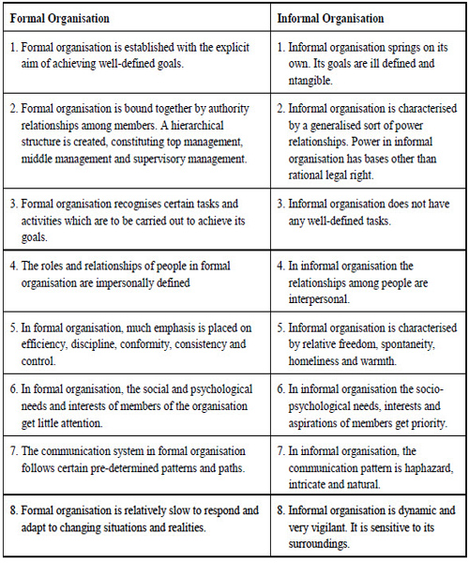

**Principles of Organising**

Principles are the guidelines that promote managerial thinking and action. Principles help managers in effectively carrying out the organising function.

**These principles are as follows:**

**Principle of Unity of Objectives:-**All organisational activities are geared towards organisational objectives. Objectives are framed for each level (top, middle and low) and each functional area. The objectives must be clearly understood by all. They should support each other at each level to attain objectives at higher levels.

**Organisational Efficiency:-**Organisational goals should be achieved efficiently. It means optimum (efficient) use of resources, that is, maximum output should be achieved with minimum inputs. The resources should be spread over activities in various functional areas that collectively result in maximum output through their optimum use.

**Division of Labour:-**Division of labour means breaking the main task into smaller units. The major task is broken into sub-tasks. This makes each person concentrate on his part of the job and perform it efficiently thereby, increasing the total output. Work should be divided and assigned to workers according to their skills. This leads to specialisation and contributes to organisational output.

**Authority – Responsibility:-**Authority and responsibility must go hand-in-hand. Responsibility means obligation to carry out the assigned task. To carry out this task, authority should be delegated to every person. Conversely, given the authority, the tasks assigned (responsibility) should be within the scope of authority. Authority without responsibility will result in misuse of authority and responsibility without authority will result in poor performance.

**Delegation:-**The total work load is divided into parts. A part is assigned to subordinates and authority is given to efficiently carry out that task. Top managers delegate part of their duties to lower levels and concentrate on important organisational matters. This speeds up the organisational tasks and enables the organisation to grow in the dynamic, competitive business environment.

**Scalar Chain:-**Scalar chain is the line of authority running from top to lower levels. Authority flows from top to bottom in this chain and responsibilities flow from bottom to top. This chain promotes communication amongst people at different levels and facilitates decision­ making. Every person in the chain knows his superior and subordinate.

**Span of Control:-**Span of control means the number of subordinates that a superior can effectively supervise. Exact number of employees that a manager can supervise cannot be determined. It depends upon competence of managers, nature of work, system of control, capacity of subordinatesetc.However, if manager can supervise less number of workers, there will be more levels in the organisation structure and vice-versa. Supervising few subordinates creates tall structures and supervising large number of workers creates flat structures.

**Unity of Command:-**One subordinate should have one boss. People should receive orders from their immediate boss only. This brings discipline and order in the organisation. Receiving orders from two or more bosses can create confusion and indiscipline.

**Balance:-**There must be balance between different principles of organising. Balance should be maintained between centralisation and decentralisation, narrow and wide span of control etc.

**Flexibility:-**Organisation should be flexible. Changes in structure should be made according to changes in the environmental factors.

**Continuity:-**Organisation should adapt to the environmental changes for its long-run survival, growth and expansion.

**Exception:-**Every matter should not be reported to top managers. Only significant deviations should be reported up the hierarchy. Routine matters should be dealt by middle and lower-level managers. It develops lower-level managers as they deal with simple and routine problems.

**Simplicity:-**Organisation structure should be simple that can be understood by everyone. People can work efficiently in a simple structure as they are clear of various jobs and authority/ responsibility associated with those jobs. A simple structure promotes co-operation, co­ordination and effective communication in the organisation.

**Departmentation:-**It means dividing activities into specialised groups (departments) where each department performs specialisedorganisational task. All activities of similar nature are grouped in one department headed by the departmental manager. Departments can be created on the basis of geographical locations, customers, products etc.

**Decentralisation:-**It means delegation of authority to lowest-level managers. It increases the decision-making authority of lower-level managers and increases organisational efficiency.

**Unity of Direction:-**All activities of similar nature are grouped in one unit (production or marketing), headed by the departmental manager. He directs the efforts of departmental members towards a single objective; the departmental objective.

**Co-Operation:-**All individuals and departments should co-operate and help the organisation achieve its goals. Cooperation leads to teamwork and focus on a unified goal.

**Organizational Structure**

According to **Hurley**, ‘Organizational structures are patterns of relationship among the various positions in a firm and among the various people occupying the positions.”

**Design/ Forms/ Types of Organizational Structure**

All the people working in the enterprise are assigned certain jobs and for their successful accomplishment some authority is also given to them. It depends upon the nature of the job in every enterprise to think as to how authority is to be given to the employees. The different nature of the works, methods of distributing authorities and responsibilities will also be different.

**Types of organizational structure:**

* Line organization
* Line and staff organization
* Functional Foremanship
* Committee organization

**Line organization**

**Line organization** is the most oldest and simplest method of administrative organization. According to this type of organization, the authority flows from top to bottom in a concern. The line of command is carried out from top to bottom. This is the reason for calling this organization as scalar organization which means scalar chain of command is a part and parcel of this type of administrative organization. In this type of organization, the line of command flows on an even basis without any gaps in communication and co-ordination taking place.

### **Features of Line Organization**

1. It is the most oldest and simplest form of organization.
2. Line of authority flows from top to bottom.
3. Specialized and supportive services do not take place in these organization.
4. Unified control by the line officers can be maintained since they can independently take decisions in their areas and spheres.
5. This kind of organization always helps in bringing efficiency in communication and bringing stability to a concern.

### **Types of Line Organization:**

**Pure line organisation**

**Departmental line organisation**

(a) **Pure Line Organization**:-In pure line organization all persons at a given level perform the same type of work. The divisions are solely for the purpose of control and direction. The departmental divisions are made only for the sake of convenience and control.All workers perform the same type of work.

**General Manager**

**Production Manager**

**Worker**

**Worker**

**Worker**

**Worker**

***Foreman A***

***Foreman B***

#### b**) Departmental Line Organization**:-The departmental type of line organization divides the enterprise into different departments which are convenient for control purposes. There is a unity of control and line of authority flows from top to the bottom. The whole organization is put under the overall control of Chief Executive who may be called by the name of General Manager. Different departments are put under the control of Departmental Managers. Departmental managers get orders directly from the General Manager. The managers are not dependent upon each other. Every department has its own line of organization. There may be deputy managers, supervisors, workers in every department. The deputy managers get orders from the departmental manager and in turn pass them on to the supervisors.

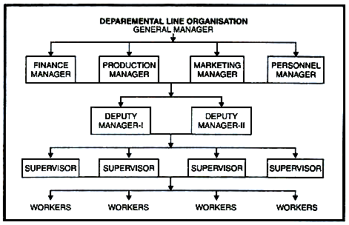

### **Merits of Line Organization**

1. **Simplest-** It is the most simple and oldest method of administration.
2. **Unity of Command-** In these organizations, superior-subordinate relationship is maintained and scalar chain of command flows from top to bottom.
3. **Better discipline-** The control is unified and concentrates on one person and therefore, he can independently make decisions of his own. Unified control ensures better discipline.
4. **Fixed responsibility-** In this type of organization, every line executive has got fixed authority, power and fixed responsibility attached to every authority.
5. **Flexibility-** There is a co-ordination between the top most authority and bottom line authority. Since the authority relationships are clear, line officials are independent and can flexibly take the decision. This flexibility gives satisfaction of line executives.
6. **Prompt decision-** Due to the factors of fixed responsibility and unity of command, the officials can take prompt decision.

### **Demerits of Line Organization**

1. **Over reliance-** The line executive’s decisions are implemented to the bottom. This results in over-relying on the line officials.
2. **Lack of specialization-** A line organization flows in a scalar chain from top to bottom and there is no scope for specialized functions. For example, expert advices whatever decisions are taken by line managers are implemented in the same way.
3. **Inadequate communication-** The policies and strategies which are framed by the top authority are carried out in the same way. This leaves no scope for communication from the other end. The complaints and suggestions of lower authority are not communicated back to the top authority. So there is one way communication.
4. **Lack of Co-ordination-** Whatever decisions are taken by the line officials, in certain situations wrong decisions, are carried down and implemented in the same way. Therefore, the degree of effective co-ordination is less.
5. **Authority leadership-** The line officials have tendency to misuse their authority positions. This leads to autocratic leadership and monopoly in the concern.

**Line and Staff Organization**

Line and staff organization is a modification of line organization and it is more complex than line organization. According to this administrative organization, specialized and supportive activities are attached to the line of command by appointing staff supervisors and staff specialists who are attached to the line authority. The power of command always remains with the line executives and staff supervisors guide, advice and council the line executives. Personal Secretary to the Managing Director is a staff official.

### **Features of Line and Staff Organization**

1. Line and Staff Organization is a compromise of line organization. It is more complex than line concern.
2. Division of work and specialization takes place in line and staff organization.
3. The whole organization is divided into different functional areas to which staff specialists are attached.
4. Efficiency can be achieved through the features of specialization.
5. Power of command remains with the line executive and staff serves only as counselors.

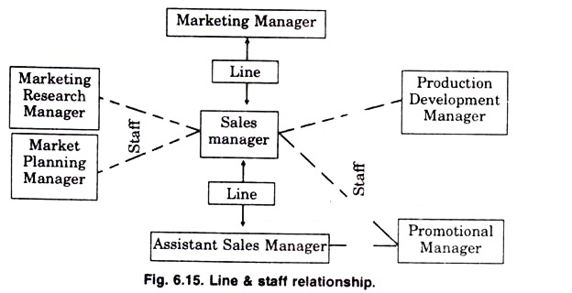

### **Merits of Line and Staff Organization**

* **Relief to line of executives-** In a line and staff organization, the advice and counseling which is provided to the line executives divides the work between the two. The line executive can concentrate on the execution of plans and they get relieved of dividing their attention to many areas.
* **Expert advice-** The line and staff organization facilitates expert advice to the line executive at the time of need. The planning and investigation which is related to different matters can be done by the staff specialist and line officers can concentrate on execution of plans.
* **Benefit of Specialization-** Line and staff through division of whole concern into two types of authority divides the enterprise into parts and functional areas. This way every officer or official can concentrate in its own area.
* **Better co-ordination-** Line and staff organization through specialization is able to provide better decision making and concentration remains in few hands. This feature helps in bringing co-ordination in work as every official is concentrating in their own area.
* **Benefits of Research and Development-** Through the advice of specialized staff, the line executives, the line executives get time to execute plans by taking productive decisions which are helpful for a concern. This gives a wide scope to the line executive to bring innovations and go for research work in those areas. This is possible due to the presence of staff specialists.

### **Demerits of Line and Staff Organization**

* **Lack of understanding-** In a line and staff organization, there are two authority flowing at one time. This results in the confusion between the two. As a result, the workers are not able to understand as to who is their commanding authority. Hence the problem of understanding can be a hurdle in effective running.
* **Lack of sound advice-** The line official get used to the expertise advice of the staff. At times the staff specialist also provide wrong decisions which the line executive have to consider. This can affect the efficient running of the enterprise.
* **Line and staff conflicts-** Line and staff are two authorities which are flowing at the same time. The factors of designations, status influence sentiments which are related to their relation, can pose a distress on the minds of the employees. This leads to minimizing of co-ordination which hampers a concern’s working.
* **Costly-** In line and staff concern, the concerns have to maintain the high remuneration of staff specialist. This proves to be costly for a concern with limited finance.
* **Assumption of authority-** The power of concern is with the line official but the staff dislikes it as they are the one more in mental work.
* **Staff steals the show-** In a line and staff concern, the higher returns are considered to be a product of staff advice and counseling. The line officials feel dissatisfied and a feeling of distress enters a concern. The satisfaction of line officials is very important for effective results.

# Functional Foremanship Organization

The line type of organisation, one person is in charge of all the activities relating to a department or section but there is a difficulty of getting men with sufficient capacity and training who can look after all the activities efficiently. Taylor, recognising this limitation, proposed a functional type of organisation. Under this type of organisation, men with special abilities or training in a specialised function may be employed. The specialists will be performing the functions which are common to different departments under one organisation.

F.W. Taylor recommended a functional organisation of activities at the shop floor level. He was of the view that the view that the foreman should not be burdened with too many activities and instead, he should be assisted by a number of specialists in solving the problems of a technical nature .F.W. Taylor has recommended the following specialists:

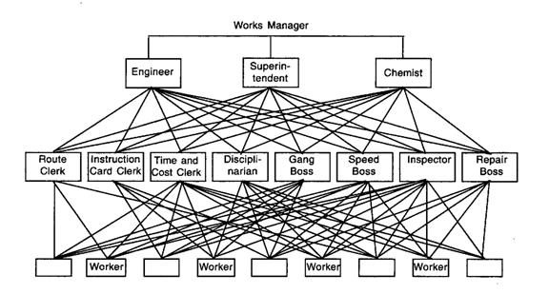

## Experts of Planning Department

**(1) Route Clerk:**His function is to lay down the exact route through which each and every piece of work should travel in the various stages of manufacture.

**(2) Instruction Card Clerk:**His function is to issue the necessary instructions to workers with regard to the manner in which they have to handle the job assigned to them.

**(3) Time and Cost Clerk:**He prepares the standard time for the completion of work and compiles the cost of that piece of work.

**(4) Gang Boss:**His work is to see that the various machines and materials are kept ready for workers to perform their operations.

**(5) Speed Boss:**His is concerned with prescribing of proper speeds for the machines.

**(6) Inspector:**His work is to check the quality of work done by the workers.

**(7) Repair Boss:**His function is to look after the maintenance of machines.

### **Merits of Functional Organization**

* **Specialization-** Better division of labour takes place which results in specialization of function and it’s consequent benefit.
* **Effective Control-** Management control is simplified as the mental functions are separated from manual functions. Checks and balances keep the authority within certain limits. Specialists may be asked to judge the performance of various sections.
* **Efficiency-** Greater efficiency is achieved because of every function performing a limited number of functions.
* **Economy-** Specialization compiled with standardization facilitates maximum production and economical costs.
* **Expansion-** Expert knowledge of functional manager facilitates better control and supervision.

### **Demerits of Functional Organization**

* **Confusion-** The functional system is quite complicated to put into operation, especially when it is carried out at low levels. Therefore, co-ordination becomes difficult.
* **Lack of Co-ordination-** Disciplinary control becomes weak as a worker is commanded not by one person but a large number of people. Thus, there is no unity of command.
* **Difficulty in fixing responsibility-** Because of multiple authority, it is difficult to fix responsibility.
* **Conflicts-** There may be conflicts among the supervisory staff of equal ranks. They may not agree on certain issues.
* **Costly-** Maintenance of specialist’s staff of the highest order is expensive for a concern.

**Committee Organization**

#### A committee is a group of people who work collectively, discuss, decide and recommend solutions to the problems (of a concern) which possibly cannot be solved by an individual. A committee consists of a group of men conversant with a subject; naturally their advice will be much superior to that of one man.

#### **Advantages of a Committee:**

#### 1. A committee often performs worth-while tasks since two experts are better than one.

2. A committee coordinates the efforts of the departments which are represented (e.g., sales, production and engineering) in development of a new product.

3. A committee is of special value in broad policy determination and rounding out plans.

4. A committee reduces the work load of management.

5. Committees are especially good at innovation or brain storming.

6. A committee helps securing co-operation of various personnel.

7. A committee is effectively used to appoint persons to fill vacant positions in the enterprise.

8. Committee meetings may be called to train younger executives and to give them a keener insight into the operation of the business.

#### **Limitations of a Committee:**

1. Sometimes it turns out to be true that what a committee finishes in a week, a good individual may complete in a day.

2. It may be said that committee operations are slow and committees tend to hang on for a considerable time.

3. An executive afraid to stand behind his own decisions may use a rubber-stamp committee and thereby share his responsibility with others.

4. In a committee, no individual can be held responsible for anything.

5. Committee decisions represent generally a compromised position and do not truly reflect the real feelings of the individual committee (or group) members.

**Departmentation**

According to **Koontz and O’Donnell**, ‘ Departmentation is a process of dividing the large monolithic functional organization into smaller and flexible administrative units”.

**Bases of organization or Departmentation**

### **On the basis of Function**:

Similar activities of a business are grouped into major departments or divisions under an executive who reports to the chief executive.This departmentation is most widely used basis for organising activities and is present in every organisation at some level.

**[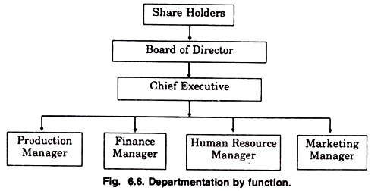](http://cdn.yourarticlelibrary.com/wp-content/uploads/2015/12/clip_image00227.jpg)**

#### **Merits**

1. It suits well the small enterprises for creating major departments.

2. It promotes specialization.

3. It economizes operations and makes possible the adoption of logical and comprehensible structure.

4. It facilitates inter-departmental co-ordination.

5. It suits well for those organisations which have single product line.

#### **Demerits**

1. It may lead to excessive centralization.

2. Decision making process is delayed.

3. Poor inter-departmental co-ordination.

4. It is rather difficult to set up specific accountability and profit centres within functional departments so the performance is not accurately measured.

5. It hinders human development in all the areas.

**On the basis of product or sevices**

In a multiproduct organisation the departmentation by product most suits. Here the activities are grouped on the basis of produce or product lines. All functions related to particular product are bought together under the umbrella of product manager. Fig. 6.7 illustrates the product departmentation.

**[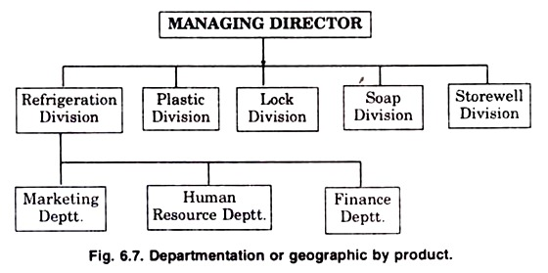](http://cdn.yourarticlelibrary.com/wp-content/uploads/2015/12/clip_image00412.jpg)**

#### **Merits**

#### 1. Each product division can be taken as a viable profit centre for accountability purposes. The performance of individual products can be easily accessed to distinguish between profitable and unprofitable products.

2. Marketing strategy becomes more pragmatic.

3. Top management is relieved of operating task responsibility and can concentrate on such centralized activities as finance, research etc.

4. It facilitates decentralization.

5. Attention is given to product lines, which is good for further diversification and expansion.

#### **Demerits**

(1) It increases management cost. Service functions are duplicated both at the top and at the operating levels of management.

(2) High cost of operation prevents the small & medium sized concerns from adopting this basis of classification, particularly for creating major units.

(3) There are problems at the top of co-ordination.

**On the basis of regions**

Departmentation by geography means, “Grouping of activities by area or territory is common in enterprises operating over wide geographic areas.” Organizations which are involved in banking , insurance , transportation. **EXAMPLE**: India could be divided into north , south , east , west , central zones. Further North Zone can be divided into Chandigarh, New Delhi, Ludhiana .

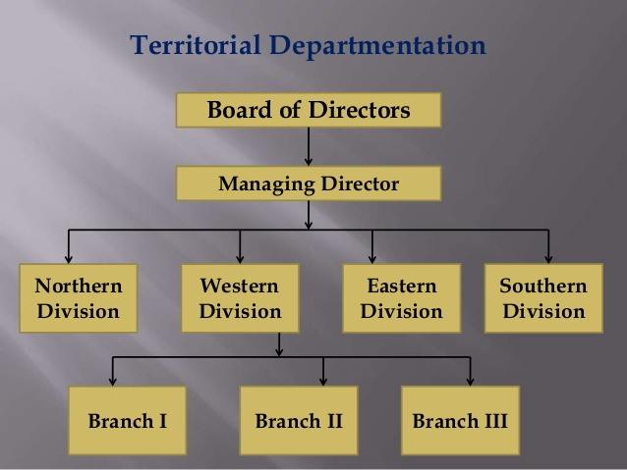

#### **Merits**

1. It helps in achieving the benefits of local operations such as local supply of materials &labour, local markets etc.

2. Full attention can be paid to local customer groups.

3. A regional division achieves a better co-ordination and supervision of activities in a particular area.

4. It helps in reducing transportation and distribution costs.

5. It facilitates the expansion of business to different regions.

6. It provides an opportunity to a regional manager to gain broad experience as he looks after the complete operation in a particular territory

#### **Demerits**

1. It creates the problem of communication and co-ordination between various regional offices.

2. It may be uneconomical due to costly duplication of personnel & physical facilities.

3. It may be difficult to provide efficient centralized services to various departments located in different areas.

4. Various regional units may become so engrossed in short term competition among themselves that the overall long term interests of the organisation as a whole may be overlooked.

5. The problem of top management control becomes difficult.

**On the basis of process**

The production function may be further subdivided on the basis of the process of production when the production process has distinct activity groups, they are taken as the basis of departmentation.

**[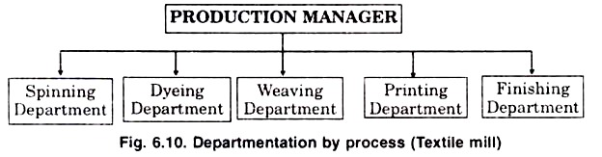](http://cdn.yourarticlelibrary.com/wp-content/uploads/2015/12/clip_image0103.jpg)**

Process departmentation is suitable when the machines or equipment’s used are costly and required special skill for operating. It is useful for organisations which are engaged in the manufacture of products which involves several processes.

#### **Merits**

1. It provides economy of operation

2. The benefits of specialization are available.

3. Efficient maintenance of equipment’s is possible.

4. It simplifies supervision and plant layout.

#### **Demerits**

1. There may be difficulties in coordinating the activities of different departments

2. Due to specialized activity, the employee mobility is reduced.

3. Extreme specialization may reduce flexibility of operations.

4. This type of departmentation may not provide opportunity for the all-round development of managerial talent.

5. Conflicts may arise among managers of different processes, particularly when they loose sight of the overall company goals.

**On the basis of customers**

Departmentation can also be made on the basis of customers served that is customer departmentation. In this case, the firm shows its paramount interest in the welfare of the customer and attention given to them. Under this method, the customers are divided into separate categories, such as distributors, retailers and consumers, and the task of satisfying the needs of different categories of customers assigned to specific departments.

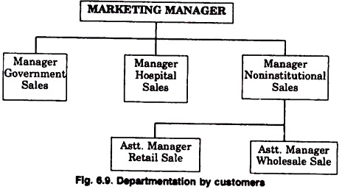

#### **Merits**

1. Customers are the key to any organization. Particularly in modern times, the needs of the customers should be satisfied effectively. This pattern of departmentation aims to satisfy the customers in a better and effective way.

2. It is highly useful where a product or service of wide variety is offered through many marketing channels and outlets.

#### **Demerits**

1. There may not be enough work in each department. Hence, some salesmen have to remain idle.

2. [Coordinating various departments](https://accountlearning.com/techniques-of-effective-coordination-in-organization/) will also pose many serious problems.

3. It may also develop an unequal development of customer groups in times of expansion and disappearance of certain customer groups in times of recession.

4. It may also create a tendency to remain rigid. Consequently, it may also become difficult to adjust to the situation in case there is a fluctuation in the activities of the enterprise.

**On the basis of matrix**

Some firms are organized by using a mix of departmentation types (matrix organization). It is not unusual to see firms that utilize the function and project organization combination. The same is true for process and project as well as other combinations. For instance, a large hospital could have an accounting department, surgery department, marketing department, and a satellite center project team that make up its organizational structure.

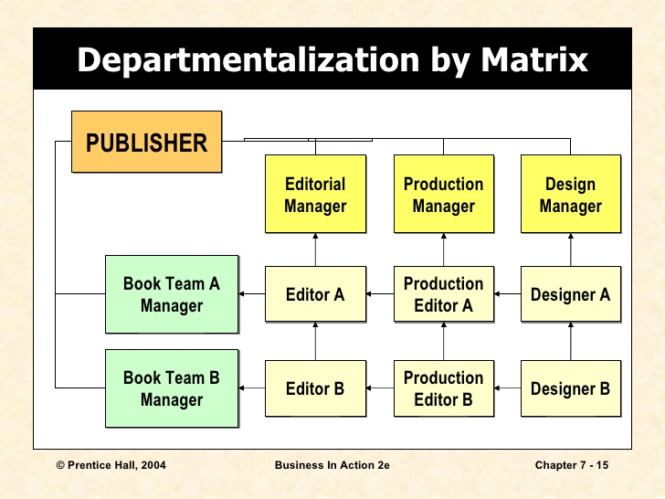

# Delegation of Authority

# A manager alone cannot perform all the tasks assigned to him. In order to meet the targets, the manager should delegate authority. Delegation of Authority means division of authority and powers downwards to the subordinate. Delegation is about entrusting someone else to do parts of your job. Delegation of authority can be defined as subdivision and sub-allocation of powers to the subordinates in order to achieve effective results.

### **Elements of Delegation**

* **Authority** - in context of a business organization, authority can be defined as the power and right of a person to use and allocate the resources efficiently, to take decisions and to give orders so as to achieve the organizational objectives. Authority must be well- defined. All people who have the authority should know what is the scope of their authority is and they shouldn’t misutilize it. Authority is the right to give commands, orders and get the things done. The top level management has greatest authority.

Authority always flows from top to bottom. It explains how a superior gets work done from his subordinate by clearly explaining what is expected of him and how he should go about it. Authority should be accompanied with an equal amount of responsibility. Delegating the authority to someone else doesn’t imply escaping from accountability. Accountability still rest with the person having the utmost authority.

* **Responsibility** - is the duty of the person to complete the task assigned to him. A person who is given the responsibility should ensure that he accomplishes the tasks assigned to him. If the tasks for which he was held responsible are not completed, then he should not give explanations or excuses. Responsibility without adequate authority leads to discontent and dissatisfaction among the person. Responsibility flows from bottom to top. The middle level and lower level management holds more responsibility. The person held responsible for a job is answerable for it. If he performs the tasks assigned as expected, he is bound for praises. While if he doesn’t accomplish tasks assigned as expected, then also he is answerable for that.
* **Accountability** - means giving explanations for any variance in the actual performance from the expectations set. Accountability can not be delegated. For example, if ’A’ is given a task with sufficient authority, and ’A’ delegates this task to B and asks him to ensure that task is done well, responsibility rest with ’B’, but accountability still rest with ’A’. The top level management is most accountable. Being accountable means being innovative as the person will think beyond his scope of job. Accountability, in short, means being answerable for the end result. Accountability can’t be escaped. It arises from responsibility.

### **Relationship between Authority and Responsibility**

Authority is the legal right of person or superior to command his subordinates while accountability is the obligation of individual to carry out his duties as per standards of performance Authority flows from the superiors to subordinates,in which orders and instructions are given to subordinates to complete the task. It is only through authority, a manager exercises control. In a way through exercising the control the superior is demanding accountability from subordinates. If the marketing manager directs the sales supervisor for 50 units of sale to be undertaken in a month. If the above standards are not accomplished, it is the marketing manager who will be accountable to the chief executive officer. Therefore, we can say that authority flows from top to bottom and responsibility flows from bottom to top. Accountability is a result of responsibility and responsibility is result of authority. Therefore, for every authority an equal accountability is attached.

### **Differences between Authority and Responsibility**

|  |  |
| --- | --- |
| **Authority** | **Responsibility** |
| It is the legal right of a person or a superior to command his subordinates. | It is the obligation of subordinate to perform the work assigned to him. |
| Authority is attached to the position of a superior in concern. | Responsibility arises out of superior-subordinate relationship in which subordinate agrees to carry out duty given to him. |
| Authority can be delegated by a superior to a subordinate | Responsibility cannot be shifted and is absolute |
| It flows from top to bottom. | It flows from bottom to top. |

**Process of Delegation of Authority**

1. **Assignment of Duties -** The delegator first tries to define the task and duties to the subordinate. He also has to define the result expected from the subordinates. Clarity of duty as well as result expected has to be the first step in delegation.
2. **Granting of authority -** Subdivision of authority takes place when a superior divides and shares his authority with the subordinate. It is for this reason, every subordinate should be given enough independence to carry the task given to him by his superiors. The managers at all levels delegate authority and power which is attached to their job positions. The subdivision of powers is very important to get effective results.
3. **Fixing Accountability -** The delegation process does not end once powers are granted to the subordinates. They at the same time have to be obligatory towards the duties assigned to them. Responsibility is said to be the factor or obligation of an individual to carry out his duties in best of his ability as per the directions of superior. Responsibility is very important. Therefore, it is that which gives effectiveness to authority. At the same time, responsibility is absolute and cannot be shifted. Accountability, on the others hand, is the obligation of the individual to carry out his duties as per the standards of performance. Therefore, it is said that authority is delegated, responsibility is created and accountability is imposed. Accountability arises out of responsibility and responsibility arises out of authority. Therefore, it becomes important that with every authority position an equal and opposite responsibility should be attached.

Therefore every manager,i.e.,the delegator has to follow a system to finish up the delegation process. Equally important is the delegatee’s role which means his responsibility and accountability is attached with the authority over to here.

# Importance of Delegation of Authority

* Through delegation, a manager is able to divide the work and allocate it to the subordinates. This helps in reducing his work load so that he can work on important areas such as - planning, business analysis etc.
* With the reduction of load on superior, he can concentrate his energy on important and critical issues of concern. This way he is able to bring effectiveness in his work as well in the work unit. This effectivity helps a manager to prove his ability and skills in the best manner.
* Delegation of authority is the ground on which the superior-subordinate relationship stands. An organization functions as the authority flows from top level to bottom. This in fact shows that through delegation, the superior-subordinate relationship become meaningful. The flow of authority is from top to bottom which is a way of achieving results.
* Delegation of authority in a way gives enough room and space to the subordinates to flourish their abilities and skill. Through delegating powers, the subordinates get a feeling of importance. They get motivated to work and this motivation provides appropriate results to a concern. Job satisfaction is an important criterion to bring stability and soundness in the relationship between superior and subordinates. Delegation also helps in breaking the monotony of the subordinates so that they can be more creative and efficient.
* Delegation of authority is help to both superior and subordinates. This, in a way, gives stability to a concern’s working. With effective results, a concern can think of creating more departments and divisions flow working. This will require creation of more managers which can be fulfilled by shifting the experienced, skilled managers to these positions. This helps in both virtual as well as horizontal growth which is very important for a concern’s stability.

**Coordination**

#### **Meaning of Coordination:**

The purpose of organising, division of work, departmentation, span of management, centralisation and decentralisation, delegation of authority and organisation structure is to optimally achieve the organisational goals. This is possible if departments of the organisation are co-ordinated in a unified direction.

**Definition:-**According to Mcfarland, ‘coordination is the essence of management for the achievement of harmony of individual efforts towards tha accomplishment of group goals.”

#### **Nature of Coordination:**

#### **1. Group effort:-**Coordination integrates the efforts of individuals and departments to make them work as a group. The group works to maximise group goals as well as organisational goals. It ensures that individuals work as a group to promote their individual and organisational goals.

**2. Unity of action:-**Every individual and department has his own perspective or way of achieving the organisational goals. Coordination ensures unity of action amongst individual and departmental activities. It ensures that activities of each individual, group and department are headed towards the common goal. All activities should be performed within the framework of policies, procedures etc.

**3. Common goal:**-Each individual and department strives to maximise its goal. Maximisation of departmental goals at the cost of organisational goals can be harmful for the organisation. Coordination maintains balance amongst individual, departmental and organisational goals. It ensures that resources and tasks are assigned to individuals and departments in a manner that working of one department promotes the working of other departments.

**4. Continuous process**:-Coordination is not a one-time attempt to integrate the individual goals. It is a continuous process that keeps going as long as the organisation survives.

**5. Managerial responsibility:**-Co-ordination is the responsibility of every manager at every level for every operative function (production, finance, personnel and sales). All managers continuously coordinate the efforts of people of their respective departments.

#### **Importance of Coordination:-**

* **Interdependence of activities:**-When different units of the organisation are dependent on each other for resources or information, there is great need for coordination amongst them. Greater the interdependence, greater is the need for coordination. According to Thompson, there are three types of interdependence: pooled, sequential and reciprocal interdependence.
* **Specialisation:**-Specialisation leads to concentration on very narrow areas of job activity. Individuals tend to overlook overall perspective of the job. This requires coordination to direct all the activities towards a common goal.
* **Growing organisation:**-In growing organisations, number of people and divisions become so large that it becomes difficult for top managers to coordinate the activities performed by all of them. Various techniques of coordination (rules, procedures, plans, goals, slack resources etc.) help in unifying diverse and multiple organisational/departmental activities towards the common goal.
* **Standards of performance:**-When standards of performance against which actual performance is to be measured are too high, managers coordinate the various business activities to ensure that high performance standards are achieved.

**Leadership**

**Meaning**

Leadership is a process by which an executive can direct, guide and influence the behavior and work of others towards accomplishment of specific goals in a given situation. Leadership is the ability of a manager to induce the subordinates to work with confidence and zeal.

**Definition** :-Acoording to **Koontz and O’Donnell**, ‘leadership may be defined as the ability to exert interpersonal influence by means of communication toward the achievement of a goal.”

### **Characteristics of Leadership**

* It is a inter-personal process in which a manager is into influencing and guiding workers towards attainment of goals.
* It denotes a few qualities to be present in a person which includes intelligence, maturity and personality.
* It is a group process. It involves two or more people interacting with each other.
* A leader is involved in shaping and moulding the behaviour of the group towards accomplishment of organizational goals.
* Leadership is situation bound. There is no best style of leadership. It all depends upon tackling with the situations.

**Importance of Leadership**

* **Initiates action-** Leader is a person who starts the work by communicating the policies and plans to the subordinates from where the work actually starts.
* **Motivation-** A leader proves to be playing an incentive role in the concern’s working. He motivates the employees with economic and non-economic rewards and thereby gets the work from the subordinates.
* **Providing guidance-** A leader has to not only supervise but also play a guiding role for the subordinates. Guidance here means instructing the subordinates the way they have to perform their work effectively and efficiently.
* **Creating confidence-** Confidence is an important factor which can be achieved through expressing the work efforts to the subordinates, explaining them clearly their role and giving them guidelines to achieve the goals effectively. It is also important to hear the employees with regards to their complaints and problems.
* **Building morale-** Morale denotes willing co-operation of the employees towards their work and getting them into confidence and winning their trust. A leader can be a morale booster by achieving full co-operation so that they perform with best of their abilities as they work to achieve goals.
* **Builds work environment-** Management is getting things done from people. An efficient work environment helps in sound and stable growth. Therefore, human relations should be kept into mind by a leader. He should have personal contacts with employees and should listen to their problems and solve them. He should treat employees on humanitarian terms.

**Approaches or Theories of Leadership**

# Trait Theory

The trait model of leadership is based on the characteristics of many leaders - both successful and unsuccessful - and is used to predict leadership effectiveness. The resulting lists of traits are then compared to those of potential leaders to assess their likelihood of success or failure.

### **Advantages of Trait Theory**

* It is naturally pleasing theory.
* It is valid as lot of research has validated the foundation and basis of the theory.
* It serves as a yardstick against which the leadership traits of an individual can be assessed.
* It gives a detailed knowledge and understanding of the leader element in the leadership process.

### **Limitations of The Trait Theory**

* There is bound to be some subjective judgment in determining who is regarded as a ‘good’ or ‘successful’ leader
* The list of possible traits tends to be very long. More than 100 different traits of successful leaders in various leadership positions have been identified. These descriptions are simply generalities.
* There is also a disagreement over which traits are the most important for an effective leader
* The model attempts to relate physical traits such as, height and weight, to effective leadership. Most of these factors relate to situational factors. For example, a minimum weight and height might be necessary to perform the tasks efficiently in a military leadership position. In business organizations, these are not the requirements to be an effective leader.
* The theory is very complex

## Situation Theory

As trait approaches became more passé, new approaches to leadership began emerging that theorized that leadership was contingent on a variety of situational factors (e.g., task to be completed, leader-follower relationships/interactions, follower motivation/commitment, etc.). These new theories of leadership are commonly referred to as the situational approaches. While there are numerous leadership theorists who fall into the situational approach, we’re going to briefly examine two of them here: Fred Fiedler’s Contingency Theory and Paul Hersey and Kenneth Blanchard’s Situational Leadership Theory.

**Follower’s Theory**

The leadership ability of a person depends on his followers. In reality the leadership ability depends on the fulfillment of the necessities of the followers. Hence, in order to find out the leadership ability of a person it is important to know as to how many followers are ready to accept him as their leader.

**Behavioural Theory**

Ray A.Killian,”A leader may be basically a decision maker , an advisor , an informer, a solution giver of problems or a planner, he should present an ideal behavior before his followers.” It means even a person with all the qualities cannot be a successful leader if he does not present an ideal example before his followers.

**Group Theory**

This theory has been propounded by Kurt Lewin. According to him a leader should be studied as a group rather than as an individual because a leader is connected not with one individual but a human group.

**X and Y Theory**

McGregor expounded this theory .according to the X theory , an individual does not utilize his full capability willingly. The feeling of doing work has got to be awakened in him and he has also to be directed.

According to X point of view , work performance of the followers requires the arousing of a feeling to work and which needs guidance,while in the Ypoint of view, only guidance in sufficient.

**Path Goal Theory**

In order to find out the presence of the leadership ability in an individual, it has to be find out as to what amount of strengthand expectancy he generates among his employees. This point of view is based on expectancymodel of motivation.

**Leadership Styles**

The help of the subordinate the objectives of the enterprise are easily obtained. The methods with the help of which a manager establishes his effect on his subordinates are called styles of leadership. Different managers can have different leadership styles.

**Leadership Styles**

**Motivation based**

**Result based**

***Power based***

**Employee Oriented**

**Production Oriented**

**Negative**

**Positive**

**Free- rein**

**Democratic**

**Autocratic**

**Motivational based leadership style**

**Motivational leadership** refers to someone leading others by **motivating** them to strive for certain goals rather than simply act on orders. The **leader** tries to create a safe and trusting environment, and ensure the organization is positioned for success in its domain—for example, a company in the marketplace.

* **Positive leadership style**:-**Positive leadership** involves experiencing, modeling, and purposefully enhancing**positive** emotions. A **positive leader** is interested in his or her employees' development as well as the bottom line. High self-awareness, optimism, and personal integrity.
* **Negative leadership style**:- this style the employees are motivated not by some economic or non economic incentives but by some unhelpful behavior. It is only because of this that it is called negative style of leadership.

**Power based leadership style**

The use of power does not means that the leader always keep an unnecessary pressure on his followers, but all the style in this category are related with the authority of the leader.

* **Autocratic:-**The manager makes all the decisions and dominates team members. This approach generally results in passive resistance from team members and requires continual pressure and direction from the leader in order to get things done. Generally, this approach is not a good way to get the best performance from a team. However, this style may be appropriate when urgent action is necessary or when subordinates actually prefer this style.

### **Democratic Leadership:-**In this leadership style, subordinates are involved in making decisions. Unlike the autocratic style, this leadership is centered on subordinates’ contributions. The democratic leader holds final responsibility, but he or she is known to delegate authority to other people, who determine work projects.The most unique feature of this leadership is that communication is active upward and downward. With respect to statistics, democratic leadership is one of the most preferred styles of leadership, and it entails the following: fairness, competence, creativity, courage, intelligence and honesty.

* **Laissez‐faire** (also called free‐rein):- In this hands‐off approach, the leader encourages team members to function independently and work out their problems by themselves, although he or she is available for advice and assistance. The leader usually has little control over team members, leaving them to sort out their roles and tackle their work assignments without personally participating in these processes. In general, this approach leaves the team floundering with little direction or motivation. Laissez‐faire is usually only appropriate when the team is highly motivated and skilled, and has a history of producing excellent work.

**Result based leadership style**

The leader or manager keeps in mind the result of works. This leadership style two arguments are given with regard to the attainment of the objectives of the organization. According to the first argument, keeping in view the upliftment of the followers will automatically help the accomplishment of the objectives. According to the second arguments, rather than keeping the interest of the followers in the mind, the attention is kept centred round the new techniques of production.

**Employee- oriented leadership style:-**Employee orientation, or Blake and Mouton's concern for people, is a trait of a manager who cares about the people who work for him. For long-term motivation, employees generally want to know their leader cares about them as people. Taken to the extreme, however, employee orientation can cause a manager to overlook task failures and missed deadlines. The employee-oriented manager often has a democratic style of leadership.

**Production oriented leadership style**:-**People**-**oriented leadership** is a catch-all terms that includes coaching, affiliative and participative **leadership styles**. In each of these **styles**, **leaders** seek to build relationships with subordinates and include them in the process of operations.

UNIT-IV

# MOTIVATION

**Introduction**:-Motivating people to perform, higher than their normal physical and mental capacities, and to keep them satisfied is a very complex function of management.

**Meaning**:- Motivation is the word derived from the word ’motive’ which means needs, desires, wants or drives within the individuals. It is the process of stimulating people to actions to accomplish the goals. In the work goal context the psychological factors stimulating the people’s behaviour can be -

* Desire for money
* Success
* Recognition
* Job-satisfaction
* Team work

**Types of Motivation-**

1.Intrinsic motivation

2.Extrinsic motivation

3. Incentive motivation

4.Fear motivation

5.Power motivation

6.Attitude motivation

1.Intrinsic motivation refers to motivation that is driven by an interest or enjoyment in the task itself, and exists within the individual rather than relying on any external pressure. Intrinsic motivation has been studied by social and educational psychologists since the early 1970s. Research has found that it is usually associated with high educational achievement and enjoyment by students.

Advantages: Intrinsic motivation can be long-lasting and self-sustaining. Efforts to build this kind of motivation are also typically efforts at promoting student learning. Such efforts often focus on the subject rather than rewards or punishments.

Disadvantages: Efforts at fostering intrinsic motivation can be slow to affect behaviour and can require special and lengthy preparation. Students are individuals, so a variety of approaches may be needed to motivate different students. It is often helpful to know what interests one's students in order to connect these interests with the subject matter. This requires getting to know one's students. Also, it helps if the instructor is interested in the subject.

2.Extrinsic motivation comes from outside of the individual. Common extrinsic motivations are rewards like money and grades, coercion and threat of punishment. Competition is in general extrinsic because it encourages the performer to win and beat others, not to enjoy the intrinsic rewards of the activity.

Advantages: Allows individuals to become easily motivated and work towards a goal.

Disadvantages: Motivation will only last as long as the external rewards are satisfying.

**Nature of Motivation-**

1. Motivation is an inner feeling which energizes a person to work more.
2. The emotions or desires of a person prompt him for doing a particular work.
3. There are unsatisfied needs of a person which disturb his equilibrium.
4. A person moves to fulfil his unsatisfied needs by conditioning his energies.
5. There are dormant energies in a person which are activated by channelizing them into actions.

**Process of Motivation-**

1.Need Identification

2.Tension

3.Effort

4.Performance of Employee

5.Rewards and need satisfaction

## Theories of Motivation -

1.Maslow’s Need Hierarchy Theory

2.Herzberg’s Motivation Hygiene Theory

3.Alderfer’s ERG Theory

4.McClelland’s Need Theory

5.McGregor’s Participation Theory

1. Maslow’s Need Hierarchy Theory:

It is probably safe to say that the most well-known theory of motivation is Maslow’s need hierarchy theory Maslow’s theory is based on the human needs. Drawing chiefly on his clinical experience, he classified all human needs into a hierarchical manner from the lower to the higher order.

In essence, he believed that once a given level of need is satisfied, it no longer serves to motivate man. Then, the next higher level of need has to be activated in order to motivate the man.

Maslow identified five levels in his need hierarchy as shown in figure 1.0

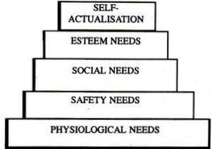

**FIG. 1.0**

Maslow’s Need Hierarchy Theory

1.1.Physiological Needs: These needs are basic to human life and, hence, include food, clothing, shelter, air, water and necessities of life. These needs relate to the survival and maintenance of human life. They exert tremendous influence on human behaviour. These needs are to be met first at least partly before higher level needs emerge. Once physiological needs are satisfied, they no longer motivate the man.

*1.2.*Safety Needs: After satisfying the physiological needs, the next needs felt are called safety and security needs. These needs find expression in such desires as economic security and protection from physical dangers. Meeting these needs requires more money and, hence, the individual is prompted to work more. Like physiological needs, these become inactive once they are satisfied.

1.3.Social Needs: Man is a social being. He is, therefore, interested in social interaction, companionship, belongingness, etc. It is this socialising and belongingness why individuals prefer to work in groups and especially older people go to work.

1. 4.Esteem Needs: These needs refer to self-esteem and self-respect. They include such needs which indicate self-confidence, achievement, competence, knowledge and independence. The fulfilment of esteem needs leads to self-confidence, strength and capability of being useful in the organisation.

1.5. Self-Actualisation Needs: This level represents the culmination of all the lower, intermediate, and higher needs of human beings. In other words, the final step under the need hierarchy model is the need for self-actualization. This refers to fulfilment.

1. Herzberg’s Motivation Hygiene Theory:

The psychologist Frederick Herzberg extended the work of Maslow and proposed a new motivation theory popularly known as Herzberg’s Motivation Hygiene (Two-Factor) Theory. Herzberg conducted a widely reported motivational study on 200 accountants and engineers employed by firms in and around Western Pennsylvania.

Herzberg’s motivational and hygiene factors have been shown in the Fig.2. 0

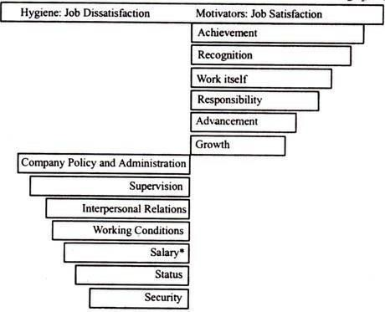

According to Herzberg, the opposite of satisfaction is not dissatisfaction. The underlying reason, he says, is that removal of dissatisfying characteristics from a job does not necessarily make the job satisfying. He believes in the existence of a dual continuum. The opposite of ‘satisfaction’ is ‘no satisfaction’ and the opposite of ‘dissatisfaction’ is ‘no dissatisatisfaction’.

According to Herzberg, today’s motivators are tomorrow’s hygiene because the latter stop influencing the behaviour of persons when they get them. Accordingly, one’s hygiene may be the motivator of another.

# MANAGEMENT CONTROL

**INTRODUCTION**:-For making people act, different types of the methods like planning, the organising, the staffing, the leading etc. are used. But after the people start acting, generally the result that is obtained seems to be a mere waste. Now here, the role of the management of the organisation is very critical and should be performed very carefully.

The main responsibility of the management here is that it should take proper care of the fact that the results that are produced are strictly according to the objectives and none of them is a waste or use-less in the nature. This responsibility of the management of the organisation is often referred to as the

‘Controlling’.

**MEANING**:- Control is any process that guides activity towards some predetermined goals. Thus, control can be applied in any field such as price control, distribution control, pollution control, etc. However, control as an element of management process can be defined as the process of analysing whether actions are being taken as planned and taking corrective actions to make these to conform to planning. Thus, control process tries to find out deviations between planned performance and actual performance and to suggest corrective actions wherever these are needed.

**Features of Controlling :-**

1. An effective control system has the following features:
2. It helps in achieving organizational goals.
3. Facilitates optimum utilization of resources.
4. It evaluates the accuracy of the standard.
5. It also sets discipline and order.
6. Motivates the employees and boosts employee morale.
7. Ensures future planning by revising standards.
8. Improves overall performance of an[organization.](https://businessjargons.com/organization.html)
9. It also minimises errors.

**Principles of Controlling:-**

1.Principle of Reflection of Plans.

2.Principle of Prevention.

3.Principle of Future-Directed Control.

4.Principle of Efficiency of Control.

5.Principle of Organizational Suitability.

6.Principle of Action.

7.Principles of Standard.

8.Principles of Assurance of objective.

## Objectives of Controlling:-

1. To ensure that activities are performed in accordance with the predetermined standard that is to see that activity is achieving the desired result.
2. To know what is happening or what has actually happened in the organisation.
3. To determine the corrective action, if any, required for the achievement of goals with a minimum of time, effort and expense.
4. To coordinate the diverse activities and efforts.
5. To improve the efficiency of operations by minimizing unnecessary & wasteful actions.

**Process of Controlling:-**

Control process involves the following steps as shown in the figure:

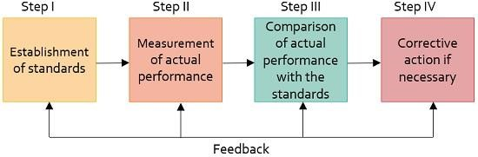

1.Establishing standards: This means setting up of the target which needs to be achieved to meet organisational goals eventually. Standards indicate the criteria of performance.

Control standards are categorized as quantitative and qualitative standards. Quantitative standards are expressed in terms of money. Qualitative standards, on the other hand, includes intangible items.

2.Measurement of actual performance: The actual performance of the employee is measured against the target. With the increasing levels of management, the measurement of performance becomes difficult.

3.Comparison of actual performance with the standard: This compares the degree of difference between the actual performance and the standard.

4.Taking corrective actions: It is initiated by the manager who corrects any defects in actual performance.

## Kinds of Control System:-

In modern organizations, there are three kinds of control

1. Concurrent control

2.Feedback control

3.Feedforward control

## Concurrent Control

This control can also be referred to as steering or real-time control. Thus, this control is associated with adjusting a performance before any high damage is done. For example, the ship’s movements are navigated by a sailor continuously. Also, a driver adjusts the steering of its car continuously.

## Feedback Control

In biological and physical systems, sometimes messages are transmitted in the mechanical form of energy. It can also be in the form of a chemical reaction or other forms. While in social systems, some information is sent back in order to exercise the control.

## Feedforward Control

This involves evaluating the various inputs. Feedforward follows a very simple principle that any organization is not stronger than its weakest link. For example, when a machine is not working properly then the operator will look for some critical components to check whether the machine is working or not.

## Control Techniques:-

1. Direct Supervision and Observation
2. Financial Statement
3. Budgetary Control
4. Break Even Analysis
5. Return on Investment (ROI)
6. Management by Objectives (MBO)
7. Management Audit
8. Management Information System (MIS)
9. PERT and CPM Techniques
10. Self-Control

**Budget and Budgetary Control**

A budget is a tool which helps the management in planning and controlling the business activities. A budget is an estimate of expected results expressed in numerical terms. There are various types of budgets like;

•           Sales budget,

•           Purchase budget,

•           Production budget,

•           Fixed budget,

•           Flexible budget,

•           Cash budget,

•           Zero base budget etc

Budgetary Control is a system of control whereby budgets are prepared for future period and compared with the actual results for finding out the variations. Corrective actions are taken in case of deviations.

**Break – Even point Analysis (BEP)**

It is the tool used to analyse the Cost – Volume – Profit relationships. BEP is the point at which there no profit no loss. In this point the total costs are recovered. If the sales go up beyond the break evenpoint , organisation makes profit. If they come down , it may secure loss.

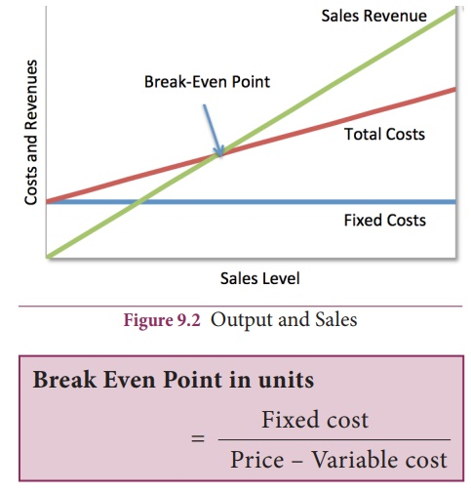

3. Return on Investment ( ROI ) – Return on Investment is one of the ratio used as a tool for measuring the overall efficiency of the firm. It shows the relationship between profits ( after interest and tax ) and the proprietors fund.

*ROI = Net Profit (after interest and tax) / Share holder fund*

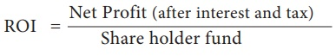

It is a powerful managerial technique.

Statistical Analysis – Statistical tools such as Percentages, averages, correlation, trend analysis etc are useful for analysis. This Statistical tools are set as standard and to find out the deviations and to find out the persons responsible for such deviations. This helps in controlling.

Management information System (MIS) – Management Information system can be defined as a systematic procedure to provide relevant information in right time, in right format to all levels of management for taking decision in business regarding inventory level , wage payment etc . The information are useful for planning , decision making and control.

External and Internal audit – External audit is done by qualified Chartered Accountant. The object of external audit is to ensure that there is no manipulation in accounts. After examining the accounting statements of the company the auditor certifies it.